**COMP1835**

**Lab 9 Working with Neo4J and Cypher language**

**Overview:**

In order to practice more complicated queries, we need a large data set. Neo4J comes with large data set, called **movies**. It also comes with a few predefined exercises that you can use to practice.

In this lab you will install **movies** data set, use predefined exercises, and then will write your code to produce required outcomes. .

You will continue using your second VM- COMP1835-graphdb

Login: **username**=student, **password**=student

**Lab 9.1 Installation of the movies data set.**

To install movies data set, **re-open** Neo4J Browser to get this pane:

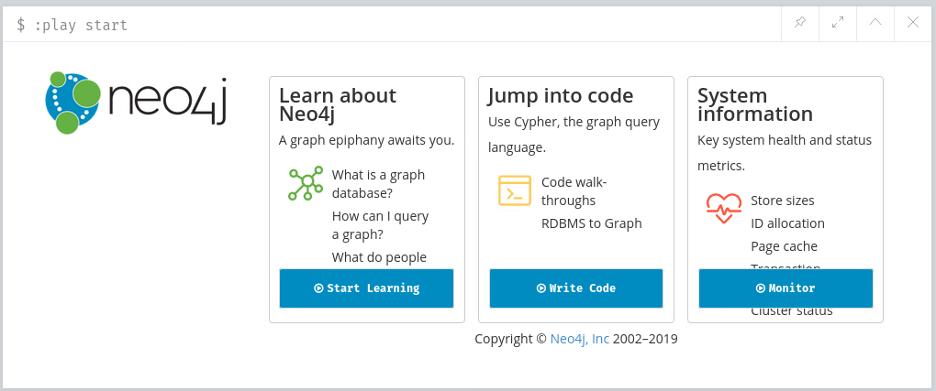

Then click on Write Code button in the section Jump into code:

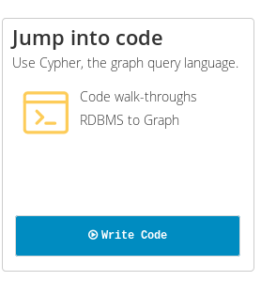

Then click on **Create a graph** button in **Movie Graph** section

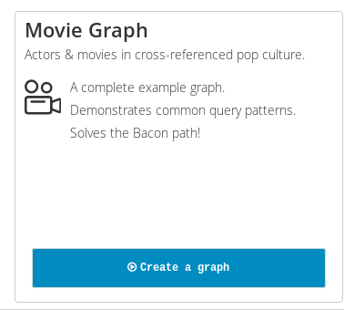

On the next screen click on the Next icon:

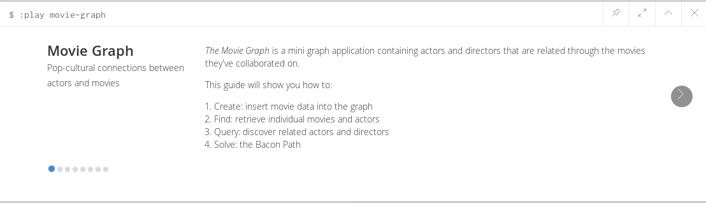

Then click Play button to load CREATE command for the movies data set into the Editor bar:

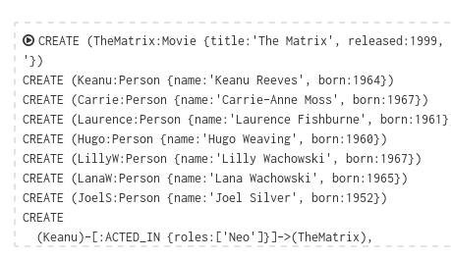

And press button Play to execute it

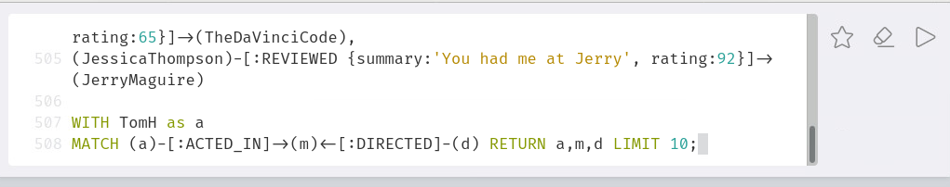

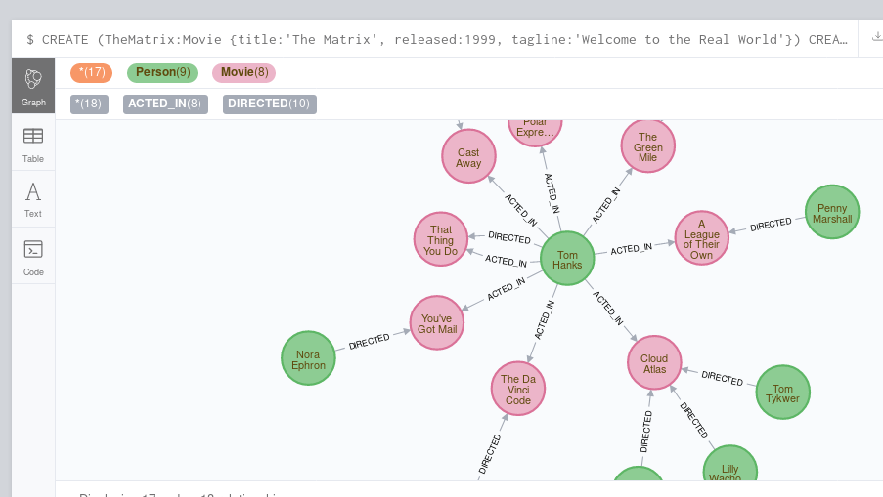

In order to understand better movies data set, investigate its schema:

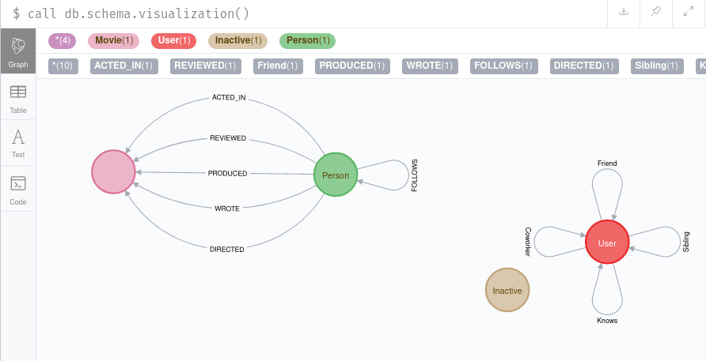

Now scroll down to return to the previous screen and

First, press pin icon to keep this pane always at the top

Second, press next icon to navigate through the exercises:

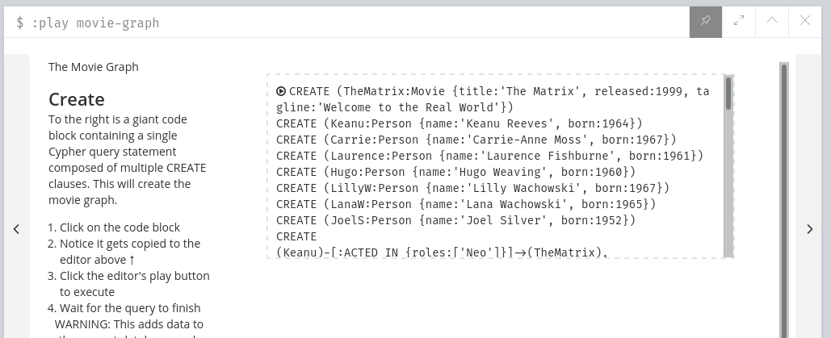

**Lab 9.2 Performing pre-define exercises.**

Next few screens offer you questions and examples of the code that will answer those questions.

**Please make sure you use them all and understand the code!**

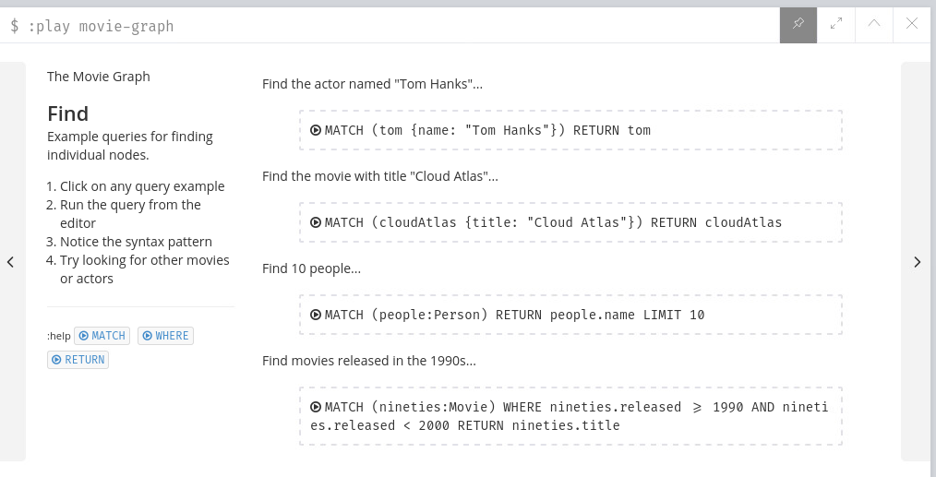

Complete all exercises by pressing Play icon next to each exercise to load the command into the Editor bar and then executing it:

1.

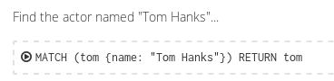

Your results will be displayed below:

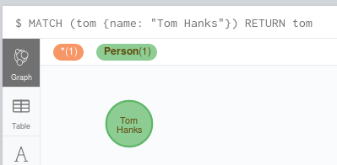

2.

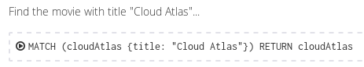

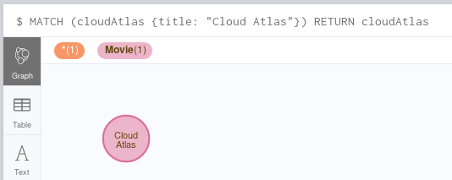

3.

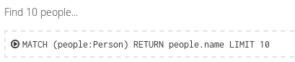

4.

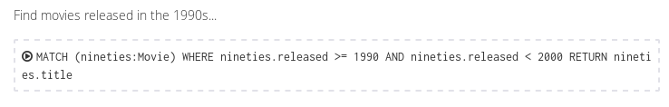

Navigate to the next set of exercises:

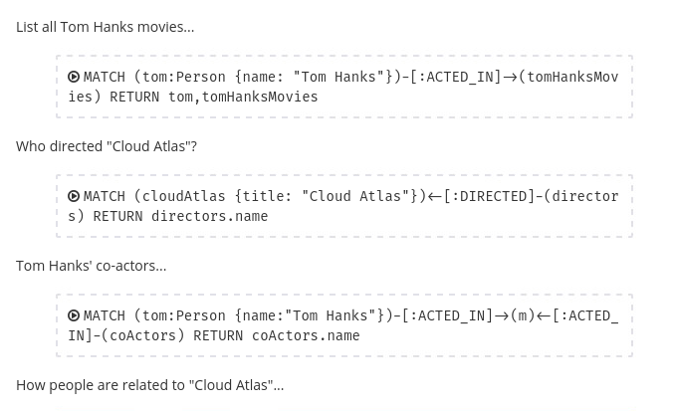

Navigate to the next set of the exercises and complete all 6 out 8



Now un-pin this screen, as we do not need it at the top anymore:

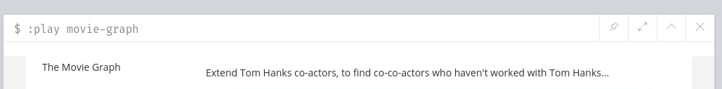

**Lab 9.3. Find more information in movies graph.**

Now, that you had a bit of a practice, answer the following questions by performing appropriate queries. Use lecture notes and Quiz notes for guidance:

1. How many actors do you have in your database? You should get 133.

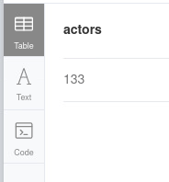

2. How many movies do you have in your database? You should get 38:

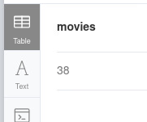

3. Now return the titles of all these 38 movies, sorted in alphabetic order by their title:

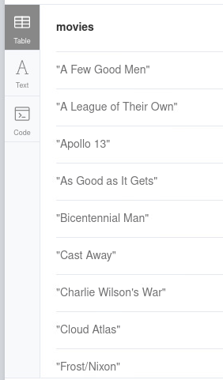

4. List the titles of all movies with Tom Cruise. You should get this:

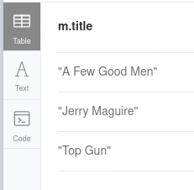

5. Find all actors who were also in the same movies as Tom Cruise. You should have 24 records:

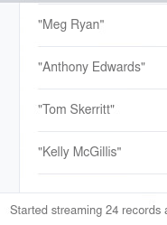

6. Find the title of the movie where Tom Cruise and Val Kilmer were together. You should get this:

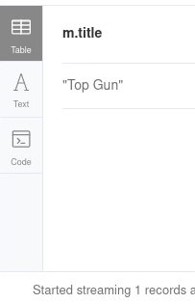

7. How many movies Meg Ryan was in? Return just the total number of the movies. You should get 5:

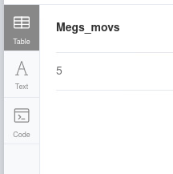

6. What is the shortest path between Meg Ryan and Tom Cruise.

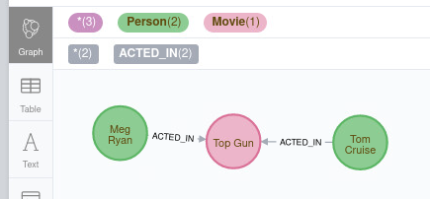

7. Display all movie titles and the names of all actors in those movies that have been directed by Lana Wachowski. You should get 24 records like these:

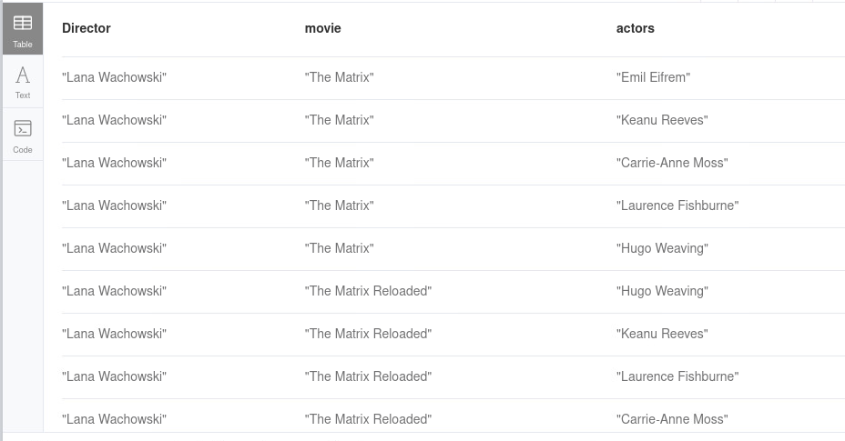

8. Find all movies, that have been directed by more than 1 director. Display the titles of these movies and the number of the directors for each.

